***Dt : 22/11/2022***

***Ex:(Program to demonstrate Producer-Consumer problem)***

***Producer.java***

***package test;***

***public class Producer implements Runnable{***

***public StringBuffer sb=null;***

***public Producer() {***

***sb = new StringBuffer();//Buffer created while Constructor execution***

***}***

***@Override***

***public void run() {***

***try {***

***//Locking the Buffer***

***synchronized(sb) {***

***for(int i=1;i<=10;i++)***

***{***

***sb.append(i+":");//Adding data to Buffer***

***System.out.println("Producer Appending data....");***

***Thread.sleep(2000);***

***}//end of loop***

***sb.notify();***

***//release the lock on buffer and Send message to next waiting thread***

***}//end of lock***

***}catch(Exception e) {e.printStackTrace();}***

***}***

***}***

***Consumer.java***

***package test;***

***public class Consumer implements Runnable{***

***public Producer prod=null;***

***public Consumer(Producer prod) {***

***this.prod=prod;***

***}***

***@Override***

***public void run() {***

***try {***

***//Locking the Buffer***

***synchronized(prod.sb) {***

***System.out.println("Consumer blocked....and Waiting for msg");***

***prod.sb.wait();***

***System.out.println("*****Display Using Consumer*****");***

***System.out.println(prod.sb.toString());***

***}//end of lock***

***}catch(Exception e) {e.printStackTrace();}***

***}***

***}***

***DemoThread5.java(MainClass)***

***package maccess;***

***import test.*;***

***public class DemoThread5 {***

***public static void main(String[] args) {***

***Producer p = new Producer();***

***Consumer c = new Consumer(p);***

***Thread t1 = new Thread(p);***

***Thread t2 = new Thread(c);***

***t2.start();//Consumer***

***t1.start();//Producer***

***}***

***}***

***o/p:***

***Consumer blocked....and Waiting for msg***

***Producer Appending data....***

***Producer Appending data....***

***Producer Appending data....***

***Producer Appending data....***

***Producer Appending data....***

***Producer Appending data....***

***Producer Appending data....***

***Producer Appending data....***

***Producer Appending data....***

***Producer Appending data....***

***\*\*\*\*\*Display Using Consumer\*\*\*\*\****

***1:2:3:4:5:6:7:8:9:10:***

***--------------------------------------------------------------------***

***Execution flow of above program:***

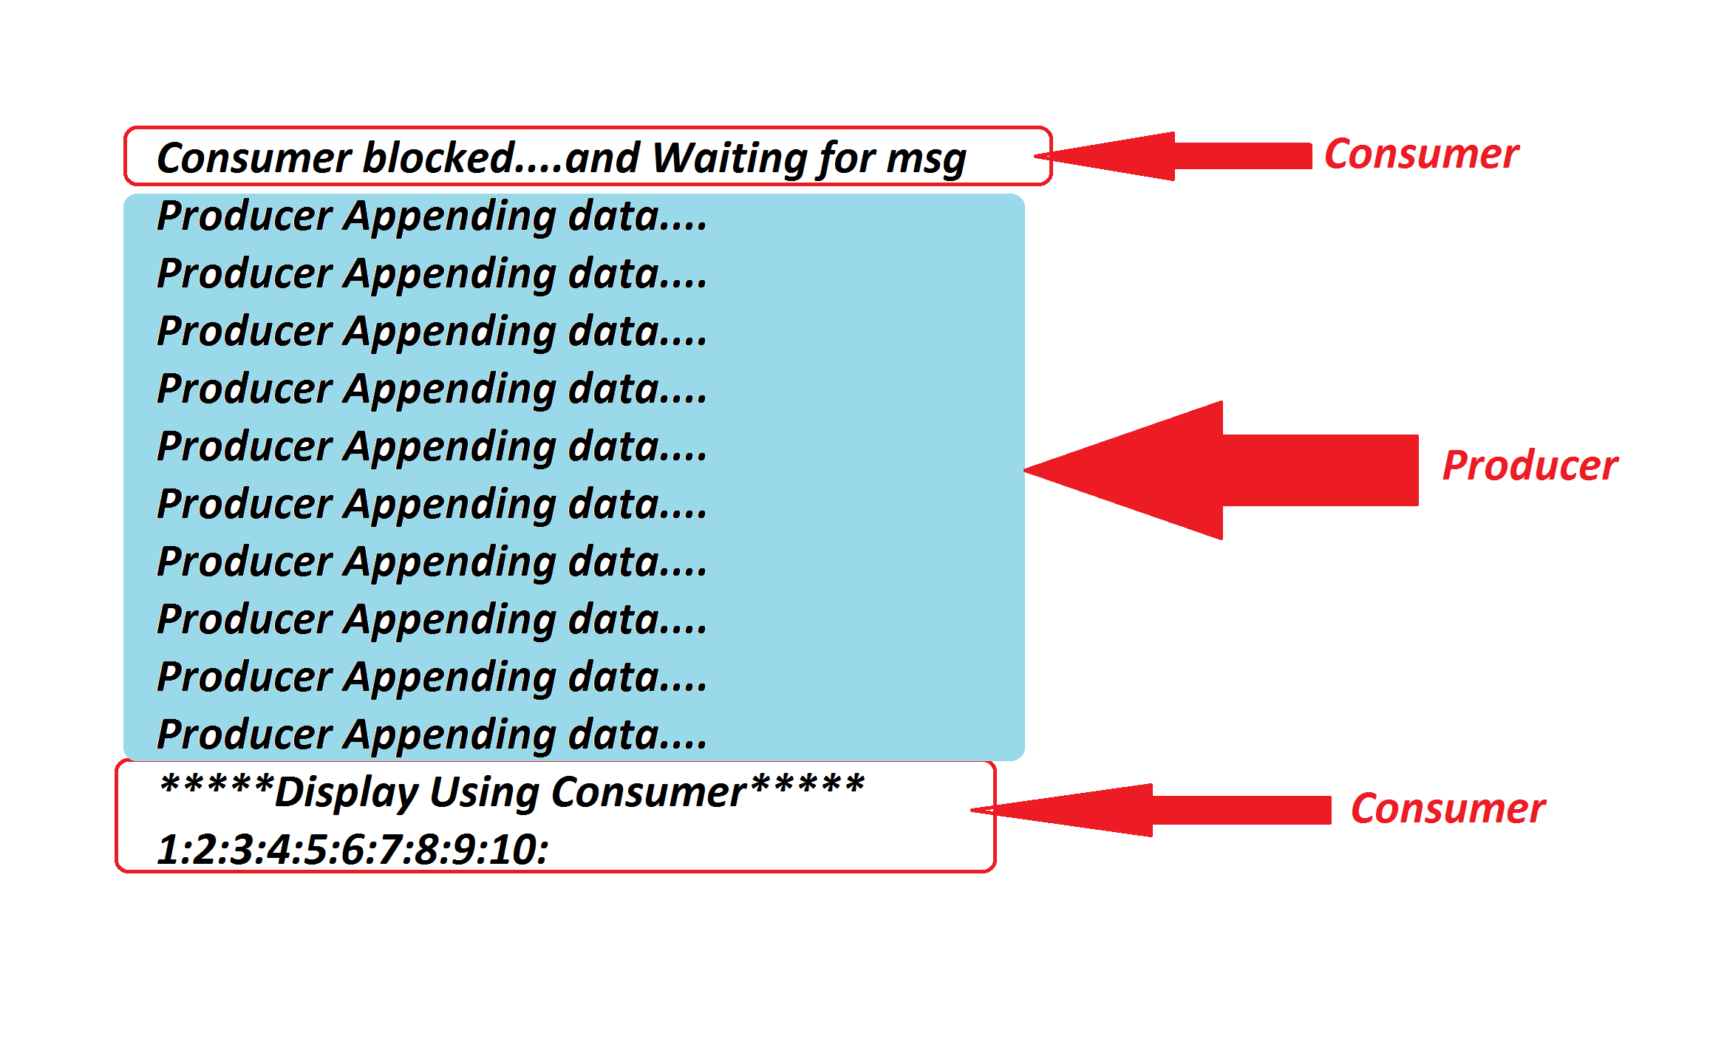

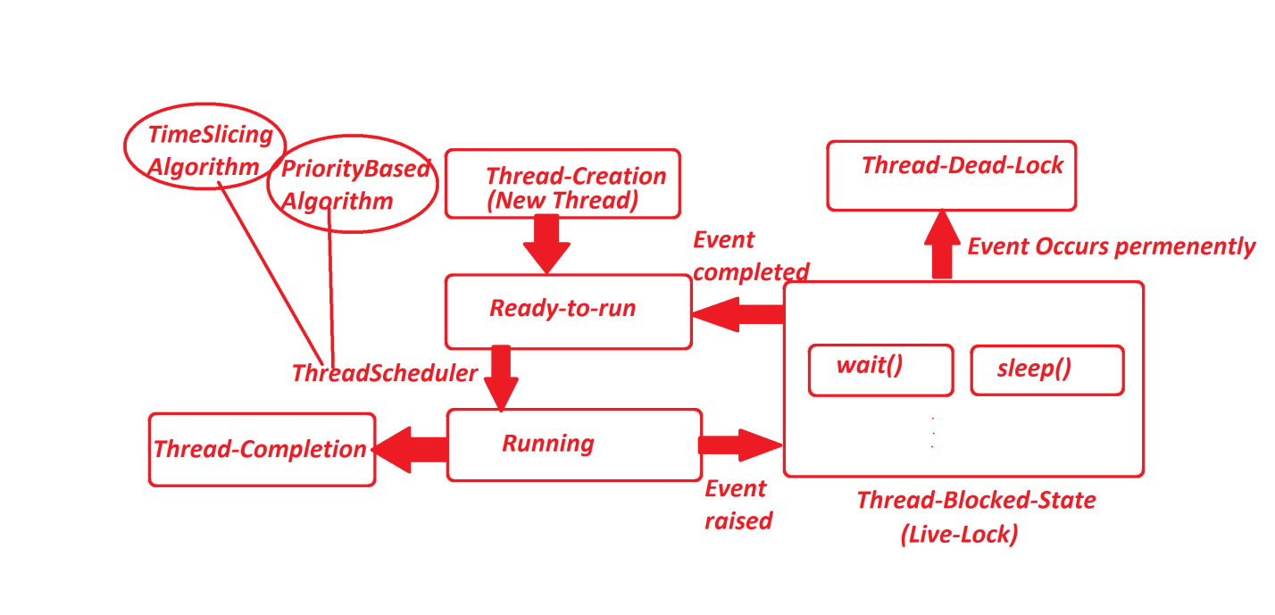

***=======================================================================***

***Note:***

***=>Consumer will wait using wait() method until Producer sends the msg in the***

***form of notify().***

***=================================================================***

***faq:***

***define Thread Life-Cycle?***

***=>Thread Life-Cycle demonstrates different states of thread from thread-creation***

***to thread-completion or thread-creation to thread-termination.***

***=>The following are the stages of thread:***

***1.Thread Creation***

***2.Ready-to-run***

***3.Running***

***(a)Thread-Completion***

***(b)Thread-Blocked-state***

***=>Thread-Dead-Lock***

***Diagram:***



